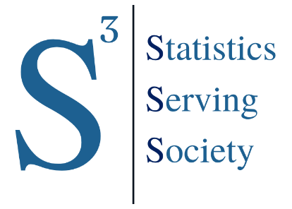
Statistics on Combatting Human Trafficking
Estimating Prevalence Methods
Zoom Breakout Room Discussion Group Questions
Instructions: Participants who join breakout rooms will be visible on camera in Zoom. Please note these will not be recorded, and will not be included in the recording of the forum session. One participant in the group will serve as a notetaker, and one will serve as the group’s facilitator.
- Select a notetaker volunteer from your breakout room to fill out this form.
- Select a facilitator volunteer to ask the questions on the form to the group.
Questions:
- Group Introductions:
Please list your group’s names and affiliations, and ask them to comment or ask a question about the presentations (the facilitator or note-taker can call on people in group). Please also identify who is the note taker and who is the facilitator.
- Estimating Prevalence Methods
There probably isn’t just one method of estimating prevalence that applies to all forms of trafficking. Which methods do you think would work best for forced labor, child labor, sex trafficking, and so forth?
- Can you think of other strategies for estimating prevalence?
- Please identify your group’s list of statistical action items that are needed to better inform public policy, generate reliable evidence, and stimulate research that may mitigate the problem.
- Are there any other comments?

Instructions after form completion:
Notetakers in the Zoom breakout rooms can send the filled-out notes in an email to Megan Glenn at mglenn@niss.org or upload your file to the online folder below:
Online Folder: Breakout Rooms Notes IOF Combatting Human Trafficking Webinar March 15 2023

